A selection of websites offering information, activities and videos on a range of topics.
Topic | May be Suitable For.. | Description | Source and Link
Food and Cooking  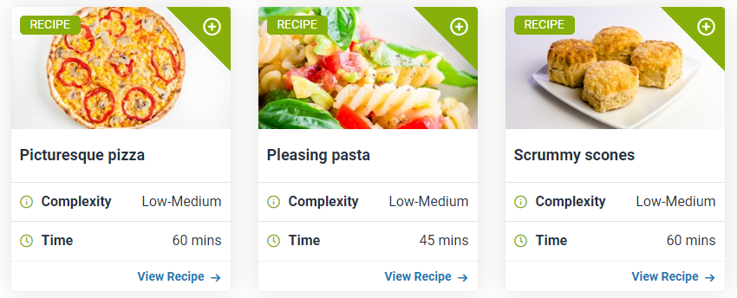 | All students.  There are resources for all abilities and interests. | This website has fantastic resources. It is straightforward and differentiated for ability. Highly recommended.  There are videos about food production.  There are picture-supported recipes that can be searched by difficulty or age range.  There are Activity Packs to support learning. | https://www.foodafactoflife.org.uk/
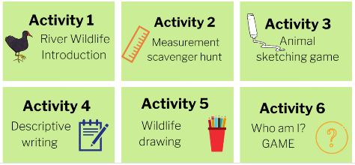  Activities about Rivers | Modular and Generic students, with differing levels of support.  Dip-in for ideas for Class-Based and High Needs students. | A lovely range of 12 activities that introduce students to the features and habitats of rivers. They can be completed as a series or dipped into for one-off activities. | www.southeastriverstrust.org  See below for how to find the activities on this website.
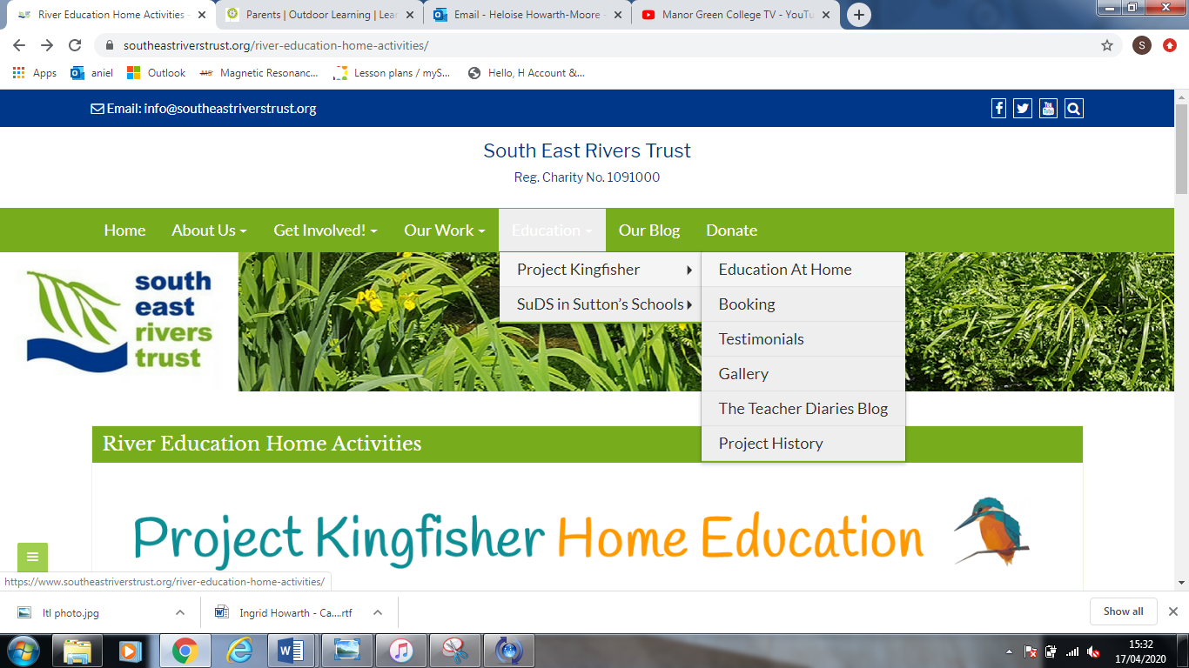
Click on Education.
Then Project Kingfisher.
Then Education at Home
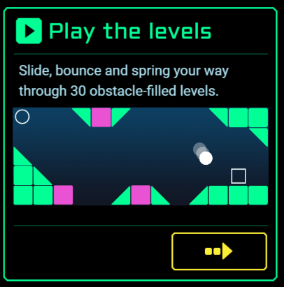  Launchball – physics based game. | Any student who likes problem-solving! | This is an old favourite of mine. It is a game but highly educational and great fun. The items have to be arranged correctly to send the ball in to the goal. It starts easy and gets progressively more difficult. The first 6 levels introduce you to some basic items – eg batteries, heat, magnets and mirrors. | The Science Museum:  Launchball:  https://launchball.sciencemuseum.org.uk/  A range of other games from the Science Museum can also be found here: https://www.sciencemuseum.org.uk/games-and-apps
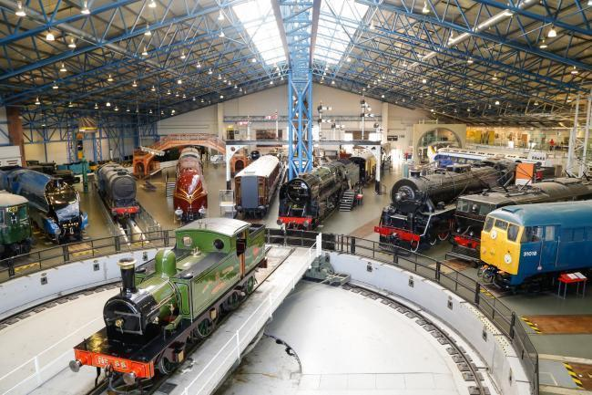  National Railway Museum | All train-loving students! | Their YouTube channel has lots of videos including special engines, history of railways, railways in films. “Never Stop Railways” is a short clip about an idea that never quite took off! The Flying Scotsman videos are also fun. | Click Here to visit their youtube channel.
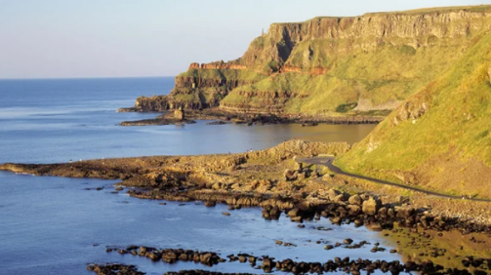  National Trust | Students who like to visit Nymans, Wakehurst and Sheffield Park. | Virtual tours including The Giants Causeway.  Lots of ideas for things to do including recipes and activities. | Click here for virtual tours.  Click here for “things to do”
Streetdance  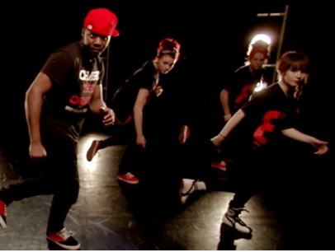 | Students who can follow moves from a screen. | This is a tutorial that teaches a 3 stage dance with some tricky moves. Good for those who like a dance challenge!  Alternatively, freestyle dancing to any music is great exercise for all students. | https://www.bbc.co.uk/teach/class-clips-video/physical-education-ks1-ks2-street-dance-masterclass-on-b-boying-and-footwork/zkmf47h
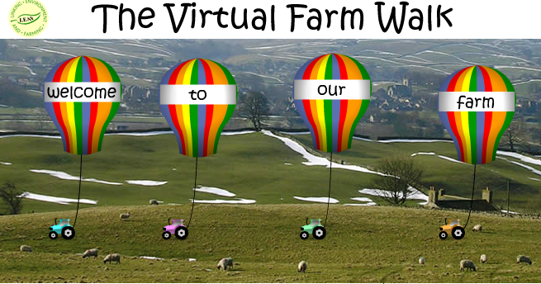  Food Production and Farm Animals | All students | Join two farmers on a virtual tour of their farm. There are various worksheets accompanying the tour which would be suitable for generic and modular class students. | You need the Adobe Shockwave player to view the virtual tour. It is available to download from the farm link below.  http://www.virtualfarmwalk.org/

Outdoor Learning  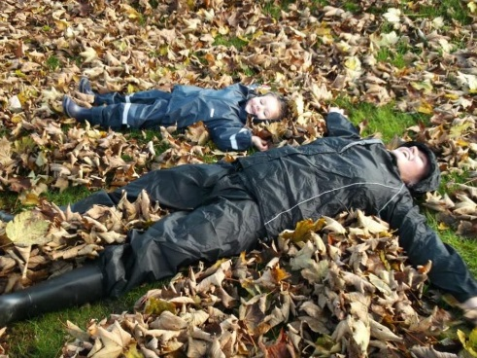 | All students with some access to outdoors, however small. |  | Useful and simple one-off ideas for outdoor learning plus downloadable weekly lesson plans if you want to take it a bit further.  I recommend dipping in and looking for something that will inspire you and your young person. | Most of the ideas are on their facebook pages:  Learning through Landscapes  And its sister page:  LtL Outdoor Learning and Play for Parents Educating at Home  They do have a website too – ltl.org.uk
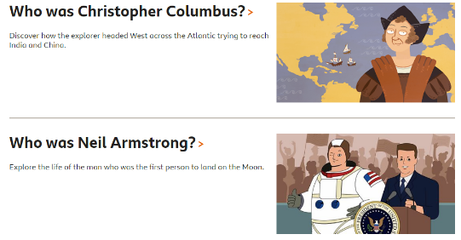  BBC Class Clips  videos about a wide range of topics | All students – there is something for everyone. | If your young person enjoys watching YouTube, why not steer them towards BBC Class clips? There are hundreds of videos on every school subject and at different levels. |  | https://www.bbc.co.uk/programmes/articles/1vYCLNlGK2wdM8R9FqhVxhV/class-clips-primary

